**Salesforce Project Documentation**

# Project Title:

## CRM Application for Public Transport Management System

|  |  |
| --- | --- |
| **S.NO** | **NAME OF THE STUDENT** |
| **1.** | Sravanam Padma Priya |
| **2.** | Ravikanth Yalla |
| **3.** | Pranav Sai Gudimella |
| **4.** | Narkidimilli M S S Praharshitha |

# Project Description:

This project aims to improve the efficiency and accuracy of managing public transport operations, specifically for Regional Transport Corporations (RTC). Built on the Salesforce platform, the application allows the management of buses, bus stations, employees, daily trips, and ticket fares. The system streamlines operational workflows like assigning drivers and conductors, scheduling trips, tracking passenger counts, and calculating total ticket fare per trip. It also enhances reporting capabilities through dynamic dashboards and real-time data insights. With automation, validation rules, and user role control, the system ensures secure, organized, and scalable transport data management.

# Project Objectives:

* Consolidate all transport-related data into one Salesforce application
* Maintain detailed employee records and assign roles (Driver, Conductor, etc.)
* Manage bus information, stations, and route assignments
* Schedule and track bus trips with driver and conductor assignment
* Calculate and track ticket fare amounts and passenger counts
* Automate internal processes using flows and Apex triggers
* Enable real-time reporting and visual dashboards for operational insights
* Implement role-based access control for secure and organized data usage

# Project Features:

* Lightning App interface to manage bus trips, employees, and stations
* Add/edit/delete buses, trips, and fare data easily
* Assign drivers and conductors based on validation logic
* Calculate total ticket fare and record passenger count
* Automate record updates using Flows and Apex
* Use validation rules to ensure proper data entry
* Generate custom reports on trip stats and employee records
* Build dashboards for revenue, trip frequency, and operational overview
* Role-based access and data visibility based on user profiles

# Project Flow & Milestones:

### Milestone 1 - Salesforce Account

Created a Salesforce Developer Account to begin application development and customization.

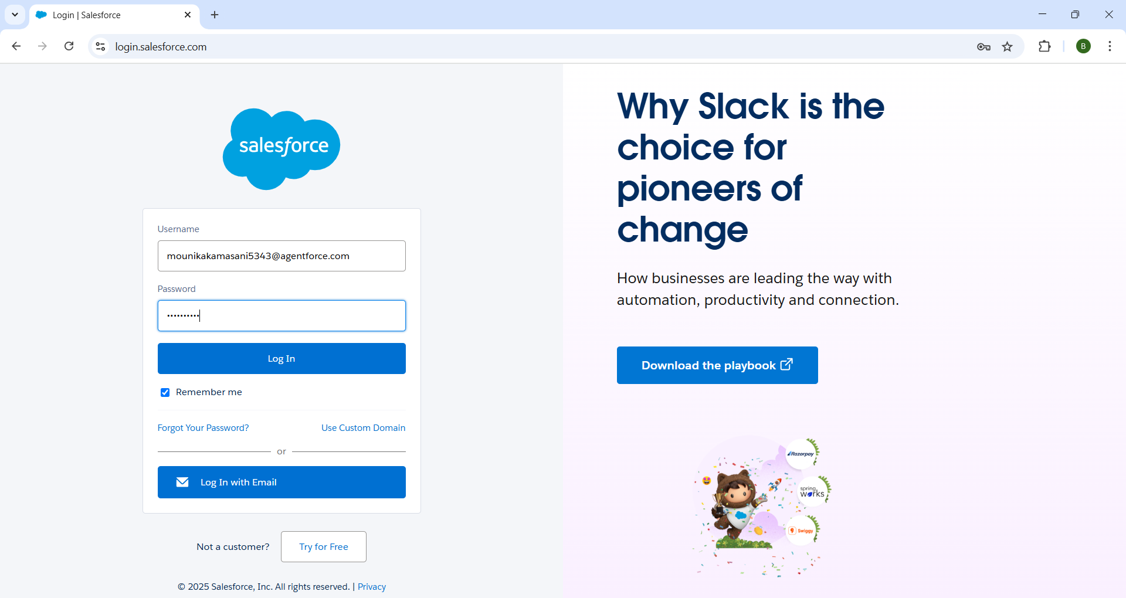

### Milestone 2 - Objects

Created custom objects including Bus Station, Bus, Trip, Ticket Fare, and Employee to capture relevant transport data.

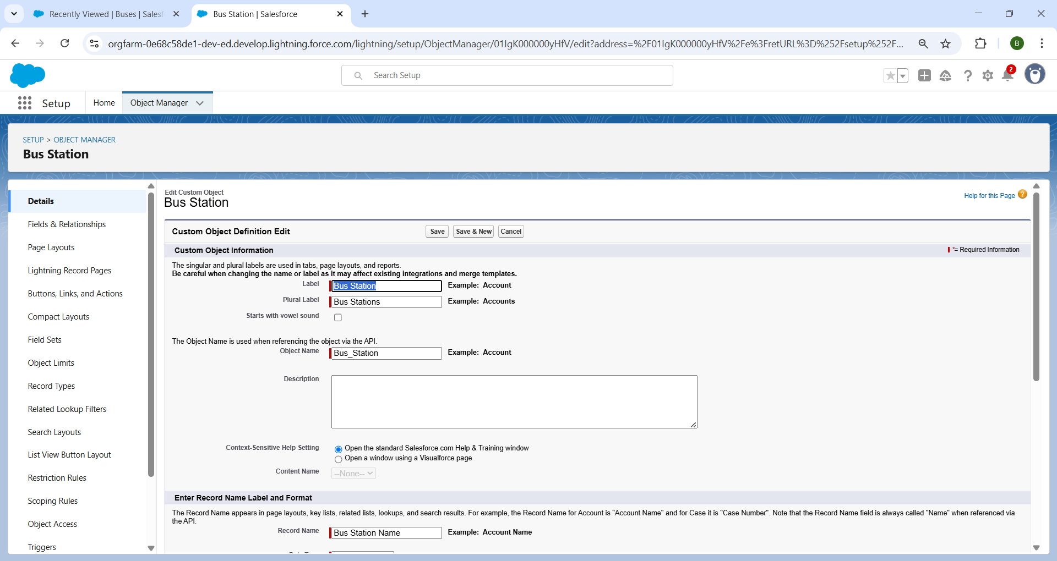

### Milestone 3 - Tabs

Created custom tabs for each object to ensure easy navigation within the Public Transport app.

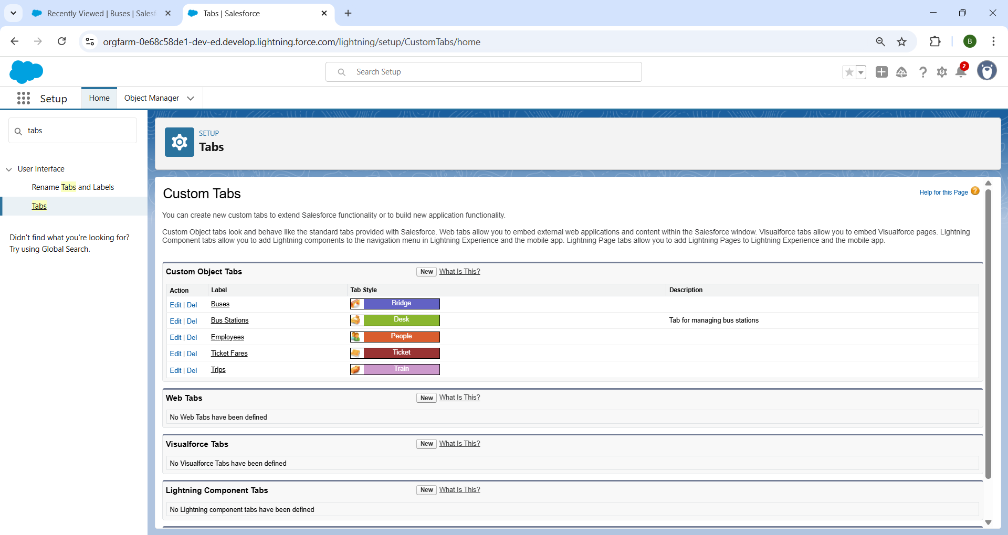

### Milestone 4 - The Lightning App

Developed a custom Lightning App called “Public Transport” combining all key objects and features.

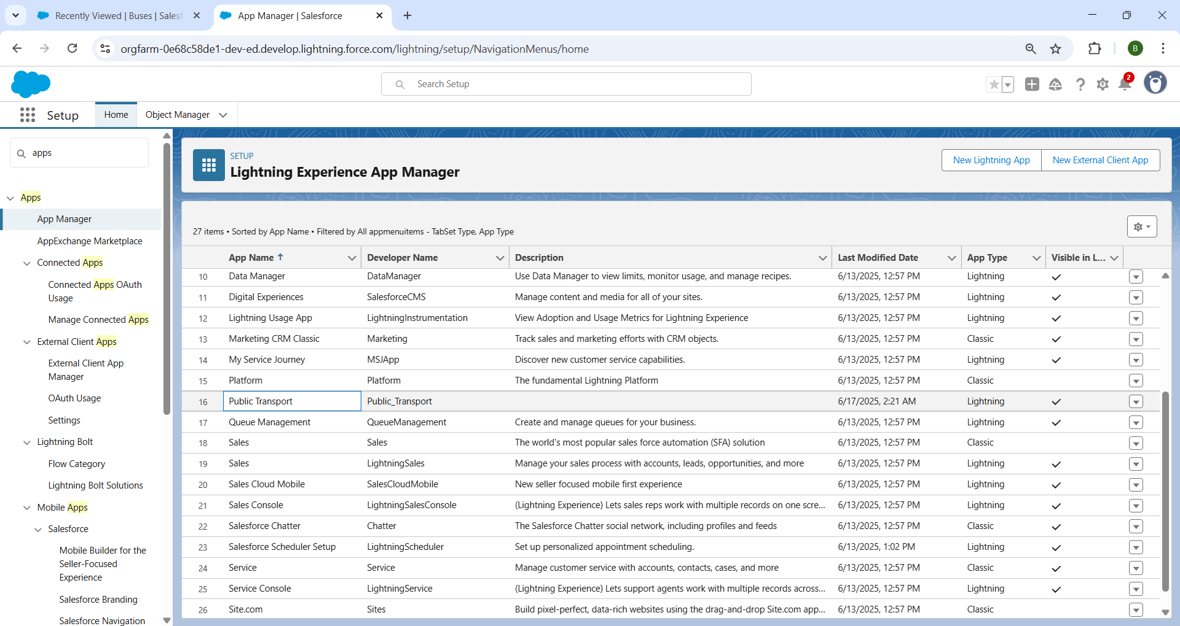

### Milestone 5 - Fields

Added custom fields like lookup, picklist, formula fields, checkboxes, etc., to capture complete object data including route, capacity, fare, and employee roles.

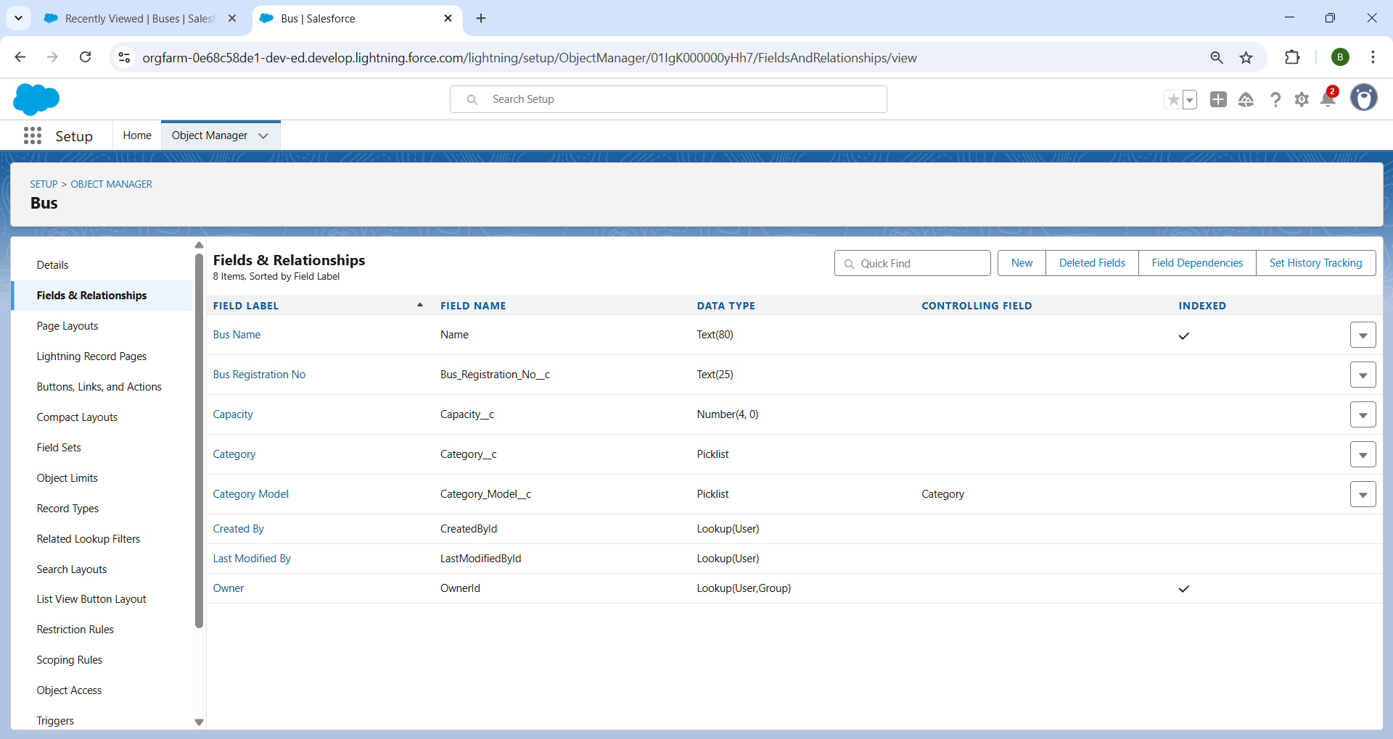

### Milestone 6- Page Layouts

Customized page layouts for each object to control visibility, grouping, and usability of record data.

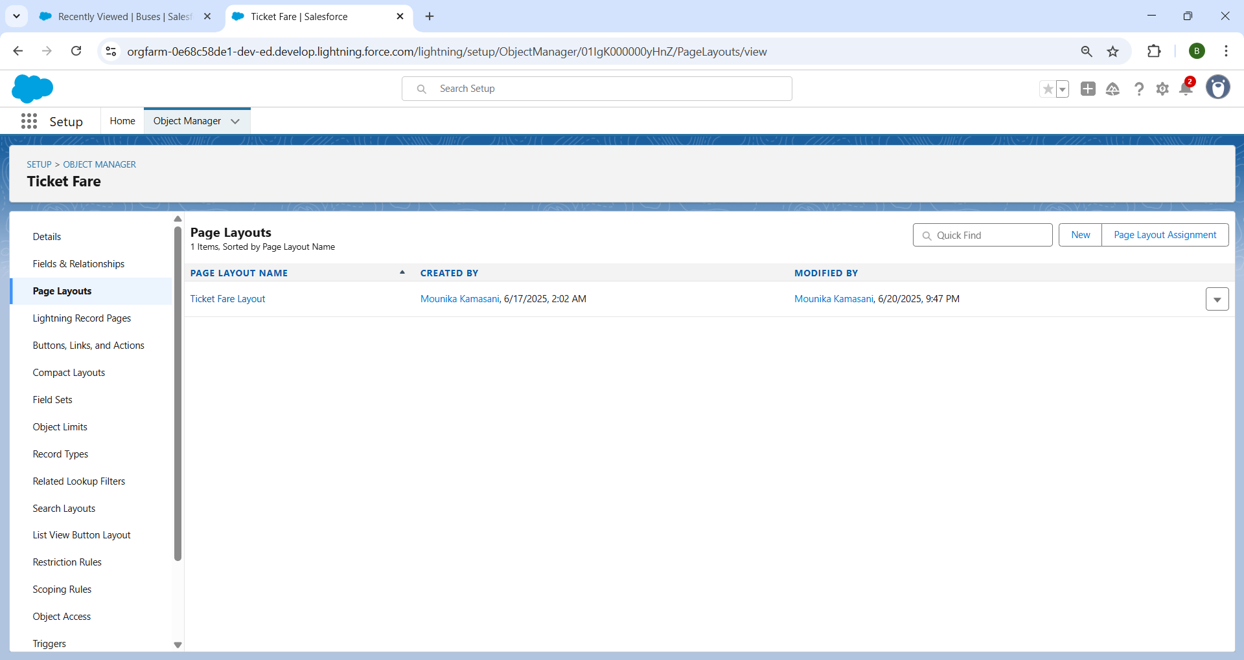

### Milestone 7- Validation Rules

Implemented validation rules to ensure correct employee role assignment (Driver/Conductor), valid phone numbers, and trip configuration.

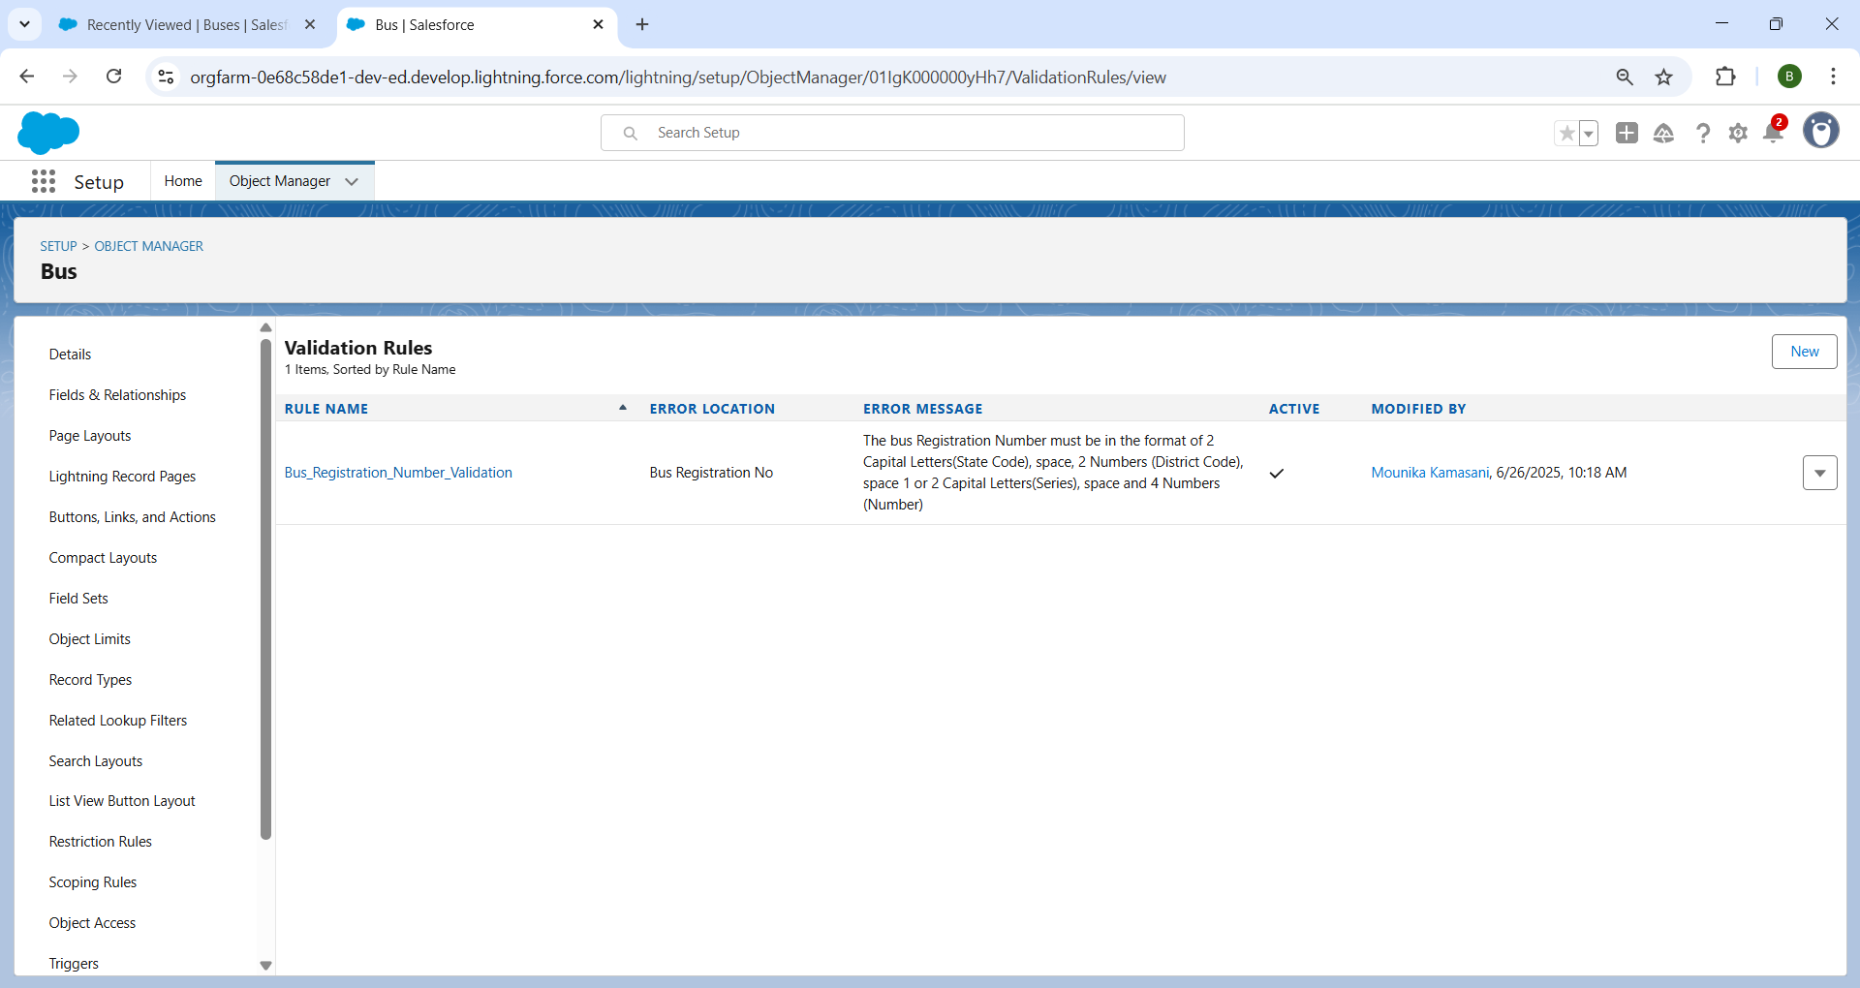

### Milestone 8 - Flows

Used Salesforce Flows to automate data handling like calculating age, retirement dates, total ticket fare, and enforcing business logic.

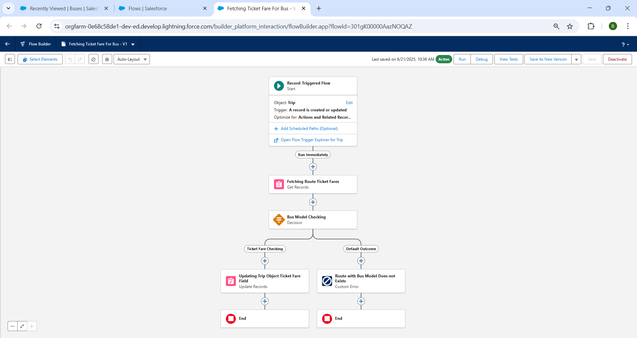

### Milestone 9 - Triggers

Created Apex Triggers and a Trigger Handler to validate whether the assigned Driver Id and Conductor Id belong to employees with correct roles.

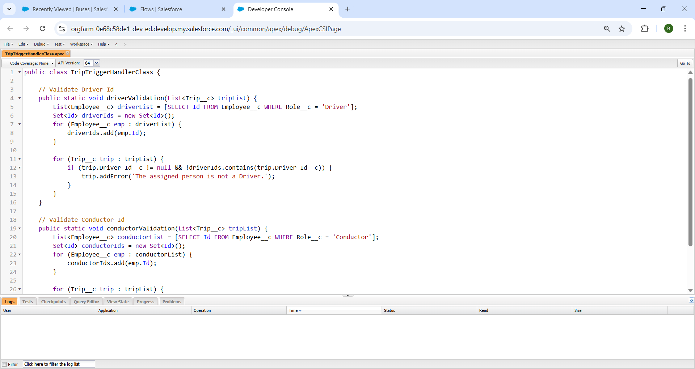

### Milestone 10 - Reports

Generated summary reports such as “Employees by Bus Station” and other custom reports to analyze operational performance.

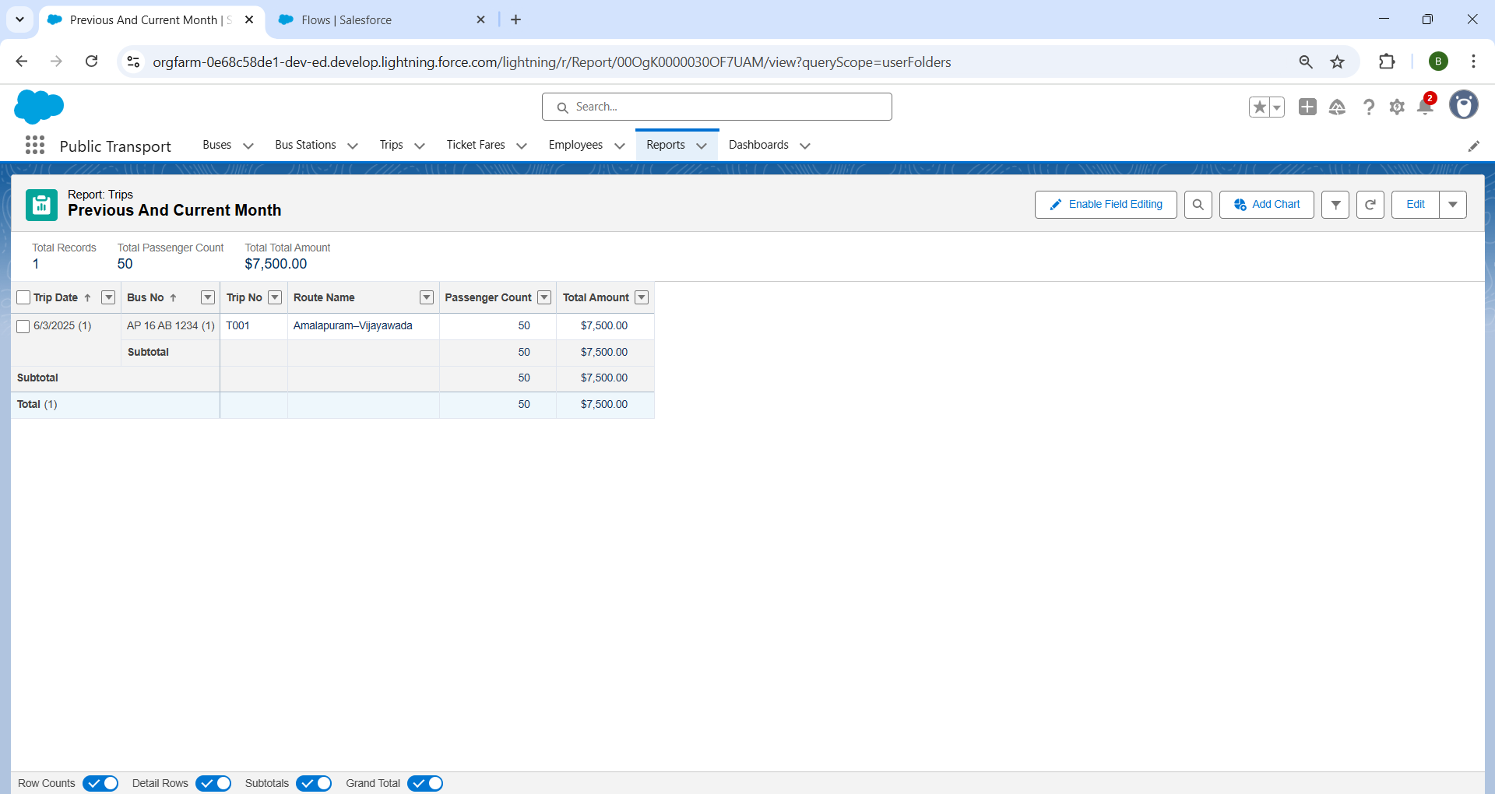

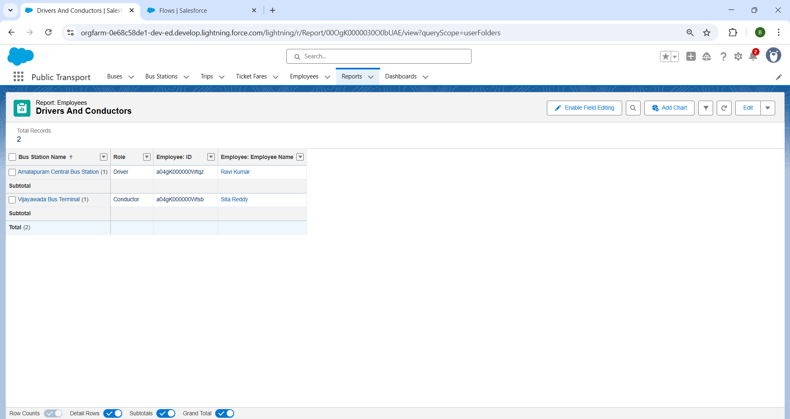

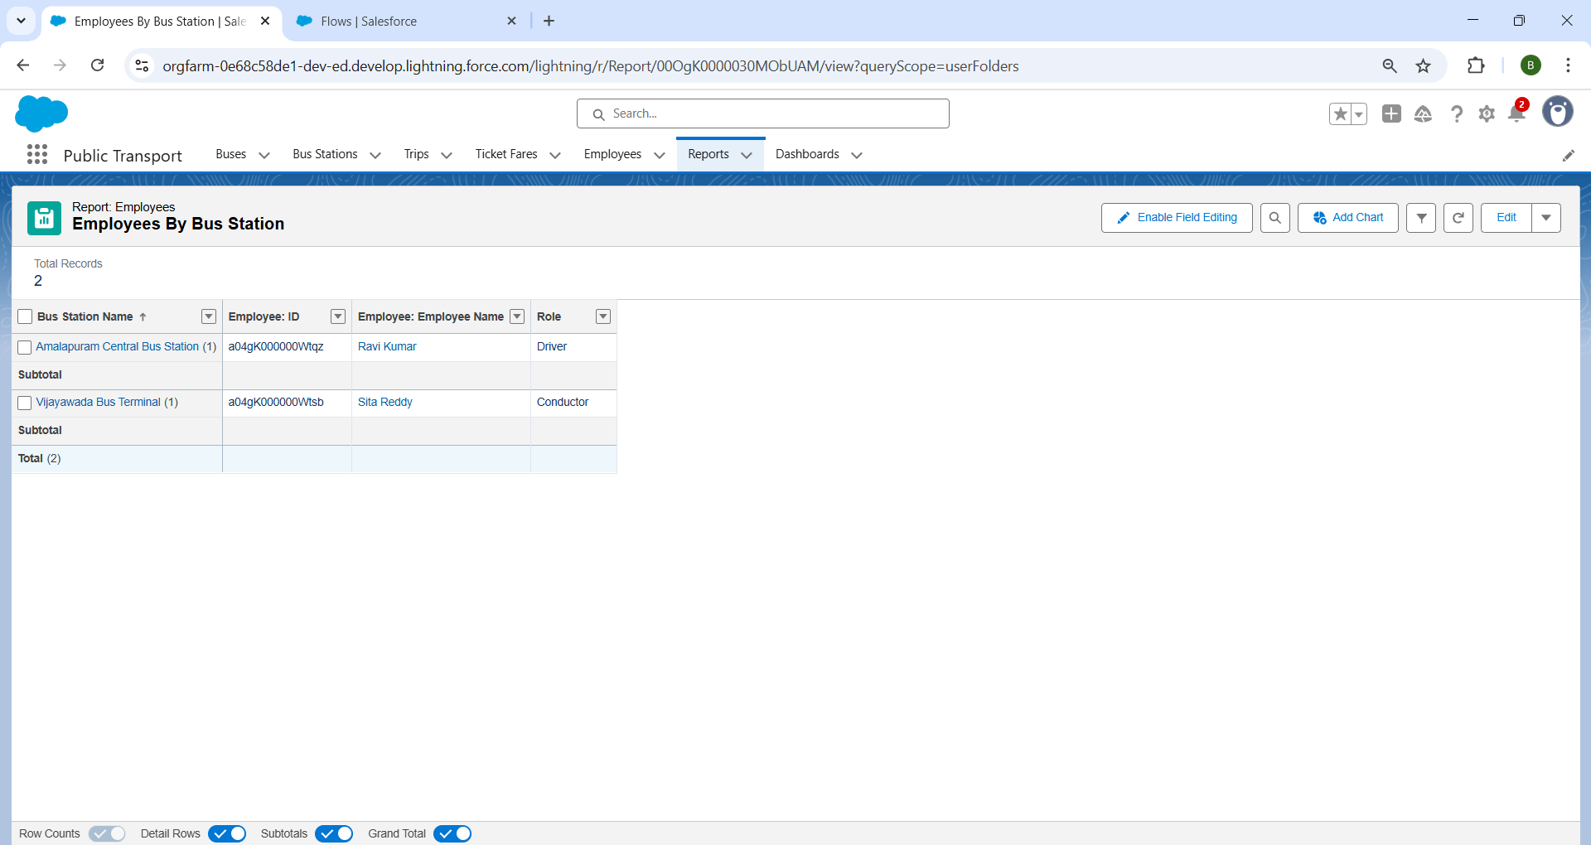

### Milestone 11- Dashboards

Built visual dashboards to present metrics like trip frequency, passenger count, and total fare collection for management insights.

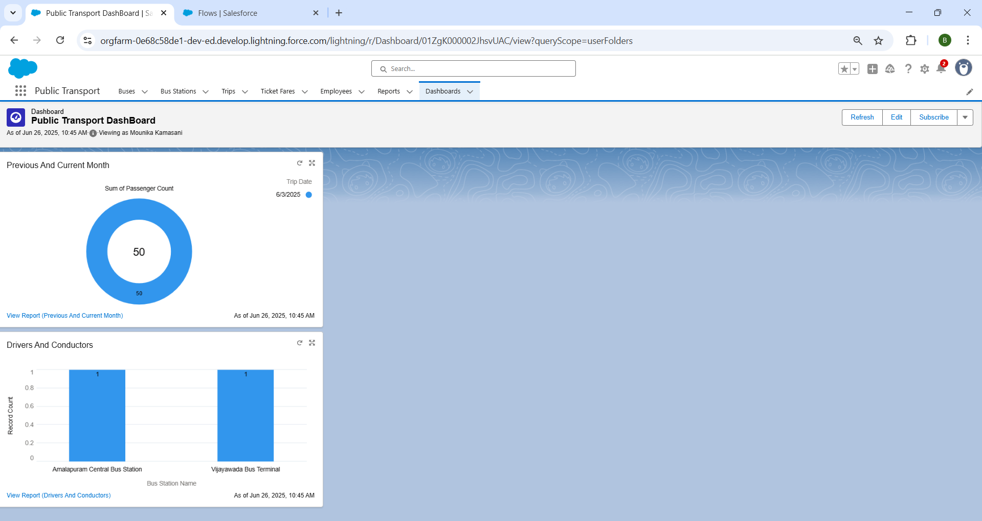

### Final Output:

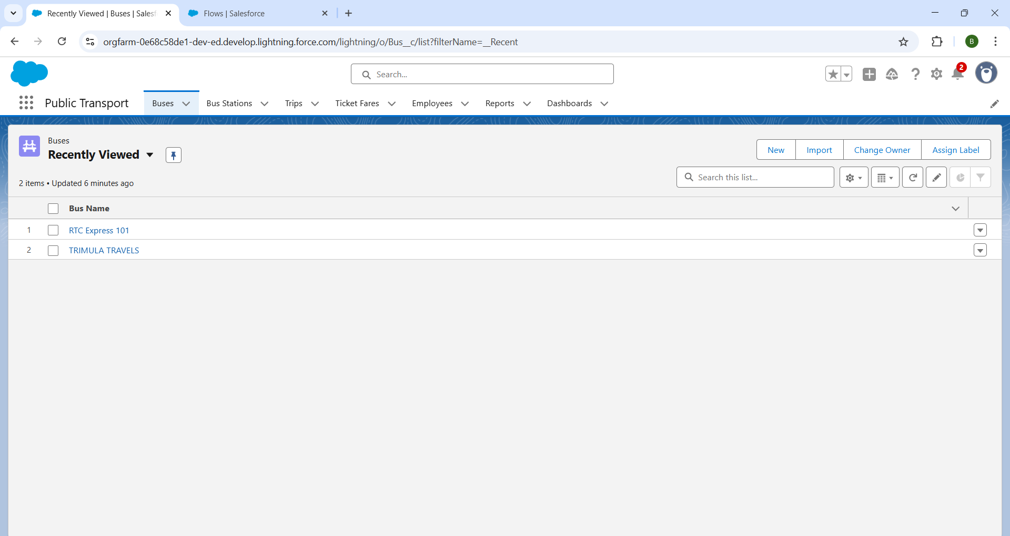

# Technologies & Tools Used:

* Salesforce Lightning Platform
* Apex (for Triggers)
* Flows (Automation)
* Custom & Standard Objects
* Reports & Dashboards
* Profiles, Roles, Permission Sets

# Learning Outcomes:

* Hands-on experience with a real-time Salesforce project
* Strong understanding of object relationships and data modelling in Salesforce
* Proficiency in Page Layout customization and Compact Layouts
* Knowledge of data validation techniques using Validation Rules
* Efficient management of user access through Profiles, Roles, and Permission Sets
* Automation of processes using Flows and Apex Triggers
* Ability to create insightful Reports and Dashboards for performance tracking

# Conclusion:

The CRM Application for Public Transport Management System developed on Salesforce provides an integrated platform for managing bus operations, staff assignments, and trip records. With automation, validation, and a centralized app interface, it enhances data accuracy, staff coordination, and operational control. Real-time dashboards and reports support better decision-making and improved service delivery for RTCs.